Best CO-Living spaces in Mumbai

Moving to Mumbai? I know it seems like a dream come true. But when we think about accommodations, our mind just cannot comprehend the daunting task of finding the perfect apartment for rent.

While living with friends and extended family has its perks no one can deny the loss of freedom it entails with it. Living alone can be boon for some but it can be too much for others.

Imagine living in an apartment shared by people who are just like you. People having same interests as you and enjoy same things as you do living together in harmony and bliss. Yes this can happen and it’s called Co-Living.

This trend is very popular abroad and well now it is just necessary in a big city like Mumbai. So let’s see the best co-living spaces in Mumbai.

1. **ZOLO NISARG ,Thane west**

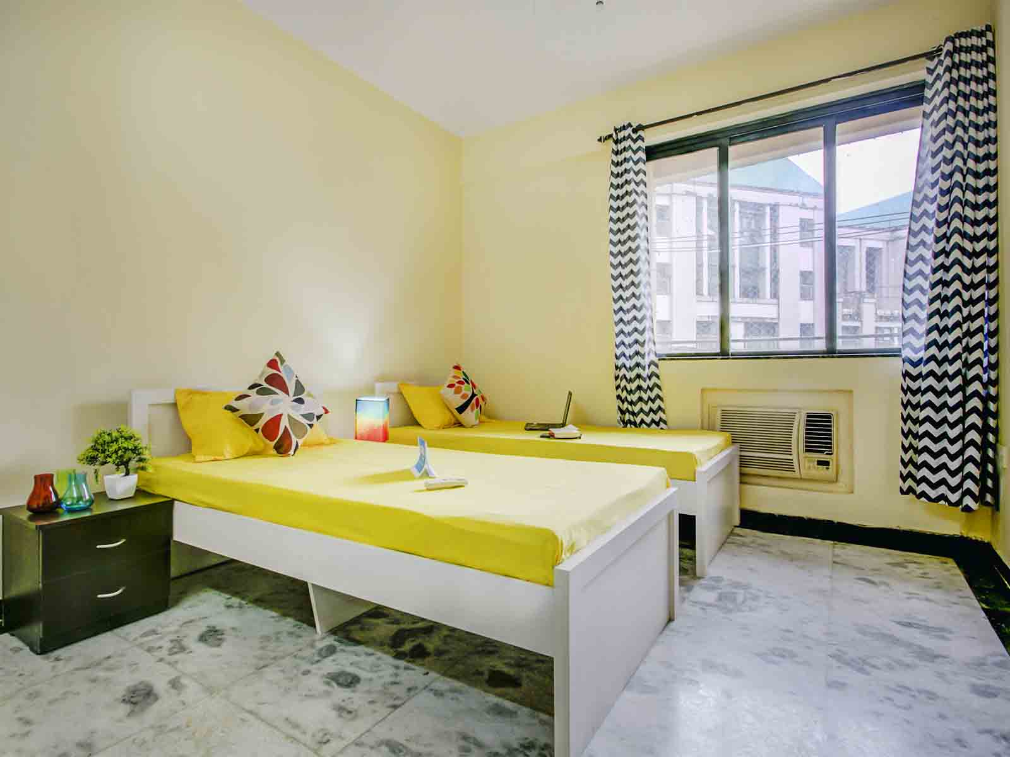

Zolo Nisarg is an amazing coliving space part of Hiranandani estate, jus opposite The Walk shopping mall. The property contains top security with CCTV cameras. It also contains various amenities like AC, refrigerator, Wi-Fi, etc. The property also has its clubhouse and swimming pool.

Rent: Rs9000 onwards.

1. **ZOLO LOGAN, Wadala**

Zolo logan is the perfect stay if you are looking for a place in Wadala. The property is located near Carnival IMAX, which makes it very convenient for movie lovers. It is situated in a commercial hub with all the restaurants, café and shops located at a convenient distance from the property. This has the best amenities for a hassle free stay with TV, AC, Wi-Fi, emergency power back up, etc.

Rent: Rs14,000 onwards

1. **ARISTA CO-LIVING SPACES, Bandra East**

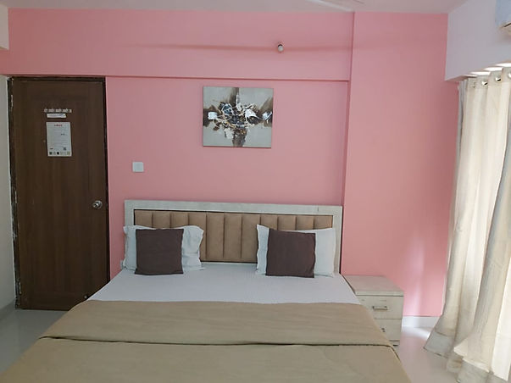

Arista coliving spaces comes with a perfect blend of modern living with cosy homestay interiors, and equipped with top amenities like AC, washing machine, TV, refridgerator, etc. It is located near Mumbai Bandra station and Bandra terminus. Also the Linking road shopping area is conveniently close by.

1. **HELLO WORLD SAGAR AVENUE, Santacruz East**

These are fully furnished coliving studio apartments located in Vakola, Santacruz. The amenities include TV, refrigerator, and various indoor games, Wi-Fi, washing machine, security, laundry, housekeeping and a beautiful view. The security deposit is just two months’ rent.

Rent: Rs15,000 onwards

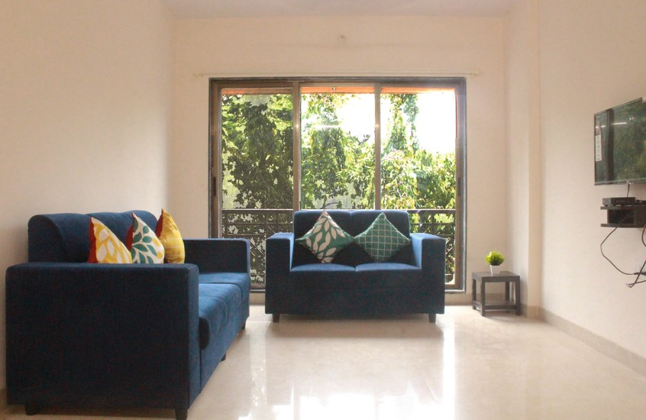

1. **PINAKI COMFORT STAY, Prabhadevi**

Prabhadevi is famous for Siddhivinayak temple which is very close to the property.The rooms are fully equipped with AC, power backup, housekeeping, Wi-Fi, TV, car parking and 24 hrs security. Prabahdevi is home to the elite, some of the prominent organisations are located here. The property is situated in the affluent residential area.

Worli sea link is located 1.7 km from the property and nearby transport location is Dadar ST bus stop. Also Shivaji Park is close by if you enjoy nature.

1. **GMD CO-LIVING**

GMD is one of the professional and renowned accommodation provider for students and working professionals all around Mumbai. The amenities are AC, TV, refrigerator, fully furnished space. It has only 45 days security deposit.

Rent: Rs7000 onwards.